

|  |
| --- |
| FusionInvest |
| Trade Workflow Short Sell Check Deal  Enhancement |
|  |

|  |
| --- |
|  |

Contents

1. Purpose 2

2. Document Control 2

3. Provision Check 2

3.1 Need to check provision 2

3.2 Check for provision 2

3.3 Short Sell 2

4. Limitations 3

# Purpose

The purpose of this document is to specify the technical requirements for a workflow check-deal for the business event in case of a short sell transaction.

# Document Control

|  |  |  |  |
| --- | --- | --- | --- |
| **Date** | **Version** | **Author** | **Comments** |
| **19-09-17** | 1.0 | Finastra | Creation of the document |
| **29-09-17** | 2 | Finastra | * Added status group criteria , * Added 4 cases for Reporting instead of just short sell * Changed the logic from modifying business event to adding an external reference |

# Provision Check

## Need to check provision

Verify the need for a provision check:

If business event has a “Number of securities” property set to “No”, i.e. then do nothing

🡺We only check provision if the business event is impacting the number of securities of the position

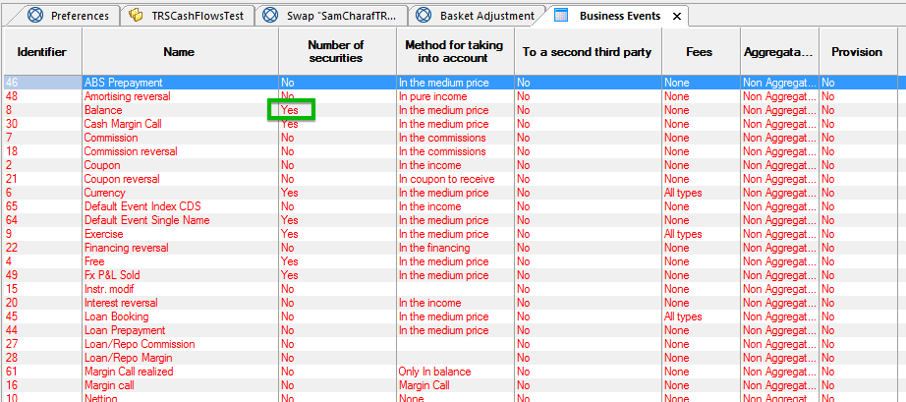

## Check for provision

1. Add the quantity of all trades in all books with the following characteristics.

- Same instrument as the current transaction.

- Same Fund (entity) as the current transaction

- Payment date of the trade <= the value date of the current trade

- Business event is ‘impacting number of securities’

- Status of the trade is in a group of transaction statuses (defined as static parameter in table MEDIO_RISKPREF – status group of validated trades)

2. Compare the result: Prov. is the total provision (excluding the quantity of the trade being tested)

* If Prov. > 0 :
  + If trade quantity is positive – Business case is Buy Long
  + If trade quantity is negative – Business case is Sell Long
* If Prov. < 0 :
  + If trade quantity is positive – Business case is Buy Cover
  + If trade quantity is negative – Business case is Sell Short

3. Set the external reference:

Depending on the Business case resulting from the provision check, the Trade external reference “RBC_REPORTING_BE” of the transaction needs to be adjusted to a specific Reporting case (defined as static parameter in configuration) to be able to report it properly to RBC :

The following cases need to be configurable:

* Buy Long
* Sell Long
* Buy Cover
* Sell Short

## Trade through zero

In the case where the Provision + trade quantity is of a different sign from the Provision, we have a trade through zero.

If Sign(Provision) <> Sign(Provision+Quanity) then External reference value = "Trading through zero"

This information will be stored in another trade external reference: "RBC_REPORTING_BE_EXCEPTION".

# Limitations

1. The provision check is done at **fund level** for a given security

**Based on end users feedback, the requirement may be adjusted to Position level or nostro account level**

1. In the case of backdated transaction being inserted in between trades of an existing position, the check will not be reapplied automatically to any already processed trade of the same position.

